
SUPPORT “TAIKO ARTS CENTER” & _____________________________

GET YOUR TREE FROM US THIS YEAR!
(Student’s Name)



1. Clearly write the full name of the person picking up the tree.
2. Write the contact phone number.
3. Write where you will pick up the tree. (Select from the lots listed below.)
* Make checks payable to “Taiko Arts Center”:
-or-
Order & Pay online at: www.HawaiiChristmasTrees.com

PLEASE PRINT CLEARLY, YOU WILL NEED TO GIVE YOUR NAME FOR TREE PICKUP

NAME | PHONE | EMAIL | TREE TYPE | TREE PICKUP LOCATION | TOTAL
JOHN DOE | 555-5555 | JOHNDOE@GMAIL.COM | 4-5 DOUGLAS | KAPOLEI HIGH | 65
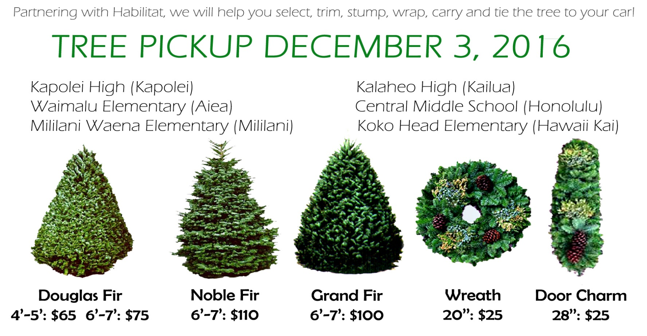



Return this envelope with payment
by 10/21/2016
to Chizuko Endo

